**California Pre-.com Bubble Real Estate**

By

Kellen Bullock

For:

Dr. Comer

On:

April 22, 2020

**California Pre-.com Bubble Real Estate**

**I. Intro**:

Until recent California’s population has been growing steadily. With the growing population the cost of housing has climbed dramatically, so high in fact that as many as 160,000 people are leaving the state per year. This study will offer a snap shot of what the housing market was before the population surge that has been happening over the past 20 years. Aptly before the time of the .com Bubble.

The dataset that will be used was gathered by R. Kelly and Ronald Barry for a Sparse Spatial Auto-regressions back in 1997. This study will be using stepwise regression of the same dataset, in attempts to see how median home price is influenced by median income, house age, average number of rooms, population, average occupancy and ocean proximity.

**Metadata**:

Total Number of Observations: 18362

Scale of Observations: Census Blocks Groups

This dataset was reduced from the original 26000 observations because of a price cap at $500,000 that covered 4000 observations. This was also observed in the age of the house at 52 years of age. To solve this a query was run that selected records that were less than $500,000 and younger than 52 years of age. The objective of this was to increase normality and help make the model more impactful at all other prices points.

The second modification to the original dataset was done to the ocean_proximity field. In the original dataset the observations were recorded as strings. I converted them into:

|  |  |
| --- | --- |
| Original Value | New Value |
| NEAR BAY | 1 |
| <1 OCEAN | 2 |
| INLAND | 3 |
| NEAR OCEAN | 4 |
| ISLAND | 5 |

Transformations that were made: natural log was used on total_rooms, population, households, and median_income to reshape the variables to a more normal distribution.



**II. Data/Variables**

**III. Methodology and Analysis**

**Factor Analysis:**

The following variables were collapsed into factors in order to reduce multicolinearity found present in correlations, variance inflation factors and condition numbers.

The method used to determine factors was the Kaiser criterion, which is whenever an eigenvalue is above 1, the variable will be picked.

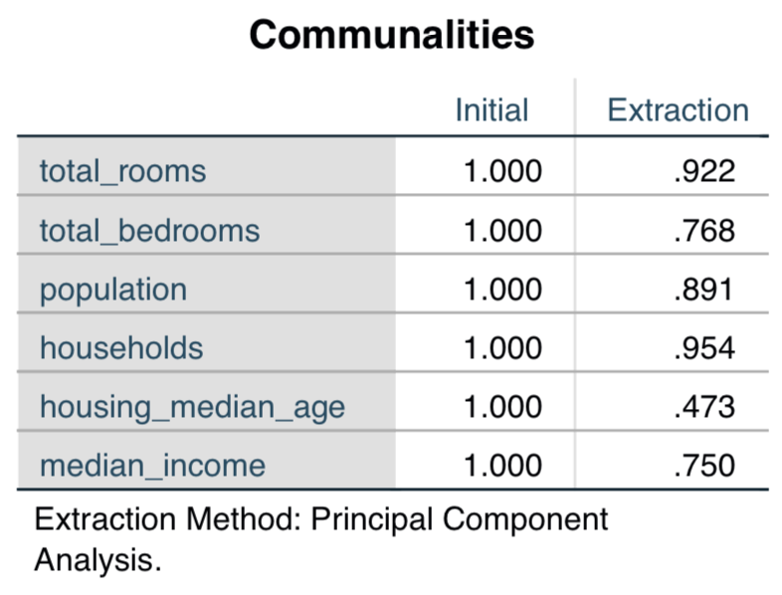

Above in the communalities table there are high extractions of the features total_rooms, and households. This indicates that these variables are very closely related.

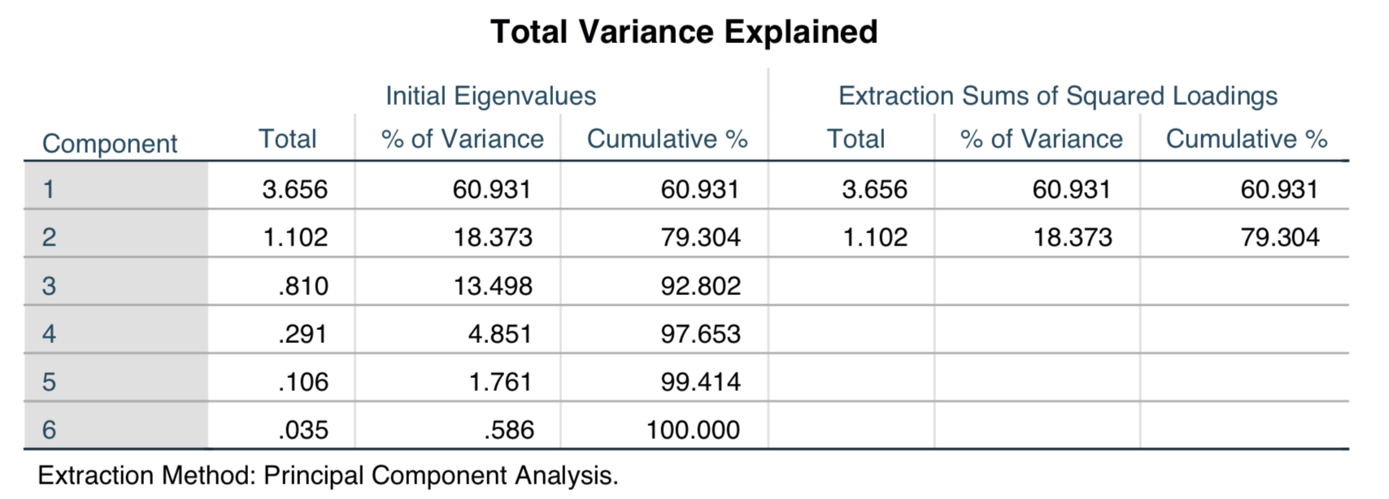

Based on the Kaiser criterion there will be only two components used from this factor analysis because their engine values are greater than 1. In addition to the Kaiser criterion there is the percent of variance drop off after the second factor as seen in the Total Variance Explained table. Further evidence for the use of only two components is in the scree plot located below. The “elbow” or large slope decrease happens after the second component.

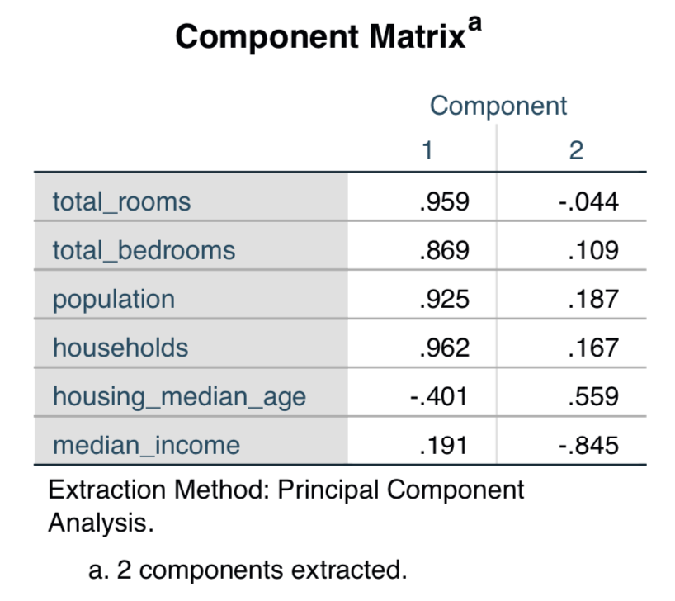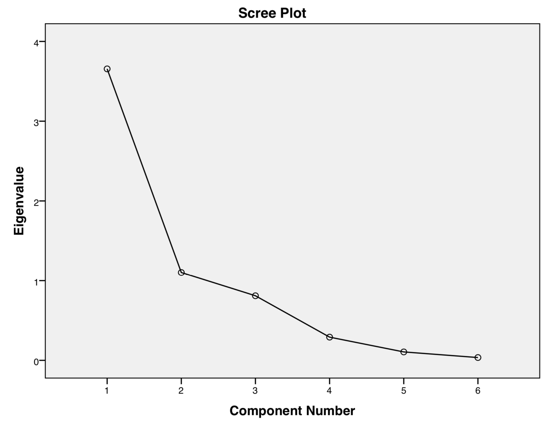

The interoperation of the first component can be made from the Component Matrix table. Since the Pearson’s R is .959 for total_rooms, .869 for total_bedrooms, .925 for population, and .962 for households, this component can be thought of as Living_Space_Density. The second component can be thought of as Shanty_Town, due to the low income and relatively older home age.

**Spatial Autocorrelation**

Before doing the regression analysis a exploratory SAC was done to grasp a better understanding of how the houses related to one another. The results are as follows:

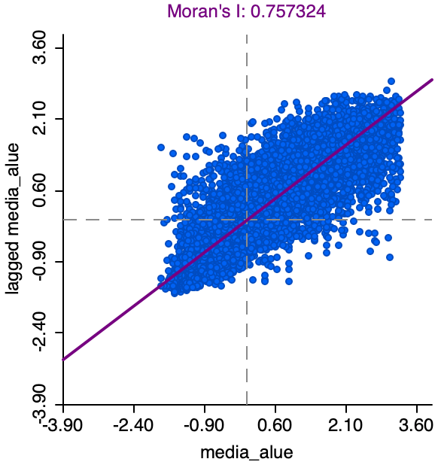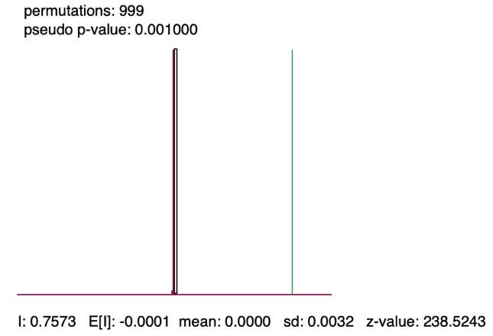

As seen above the dependent variable median house value is strongly spatially auto correlated in a clustering pattern, on the basis of a Moran’s I value of 0.757. This clustering is significant at a 0.001 pseudo p-value.

**Regression Hypothesis and Results:**

**Ho: if r-square < 0.75 there is no significance in the explanation of this model.**

**Ha: if r-square > 0.75 this model significantly explains median house value.** 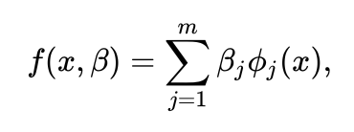

*f(x ß),* = (-21,157.232)ocean_prominity + (319,755.218)median_income + (1297.833)housing_median_age + (17.802)total_bedrooms + (8990.114)households

The best model that resulted from this study had an r-square of 0.434, with a standard error of $71,759.88 per median house value. This model was very significant with a F score of 2810.960. VIF was not an issue in this model because none of the variables were over 2.9. By determining what variables explained each other from the bivariate analysis and factor analysis mulicolinarity was eliminated. To improve the r-square, the decision to leave the factors out of the model was made. This decision resulted in a higher r-square, and an additional variable to be used.

**IV. Conclusion**

By failing to explain .25 percent of median house value, this model fails to reject the null hypothesis of explaining more than .75 percent median house value.

The following section will discus what assumptions this model made appropriately and failed. The assumptions for regression are: the dependent variable must be interval-ratio type, the trend between dependent and independent variables must be linear, the independent variables must be interval ratio, the independent variables should be reasonably shaped, and an adequate number of variables must be used.

1. The dependent variable median house value met the first assumption of regression because it was interval-ratio.
2. There were not linear trends between the dependent variable and the independent variables.
3. Not all independent variables were interval ratio, ocean proximity was a weakly ordinal.
4. Independent variables were reasonably shaped after transformation.
5. There were five variables used in the model.

Assumptions of the residuals are: there is a linear relationship, normality, they are spatially independent from one another, and are not heteroskedastic.

1. As seen in the scatterplot below there is a linear relationship between the residuals.
2. The residuals are not normally distributed, as seen from the histogram and qq-plot below.
3. Observing the Map, and Moran’s I scatterplots below show that the residuals are spatially auto correlated. Thus, meaning they are dependent on one another.
4. The residuals are not heteroskedastic, on the basis of the scatterplot pattern.

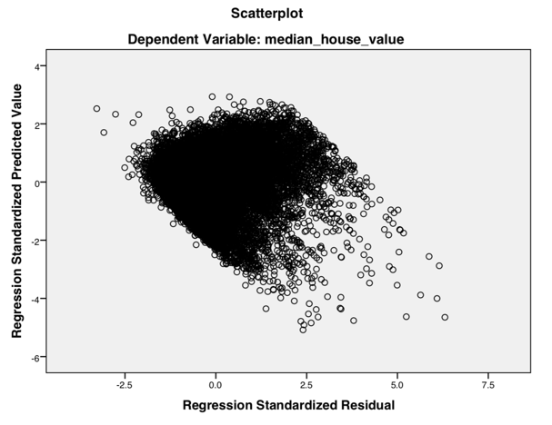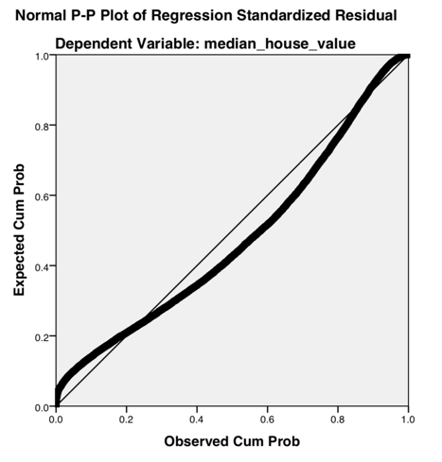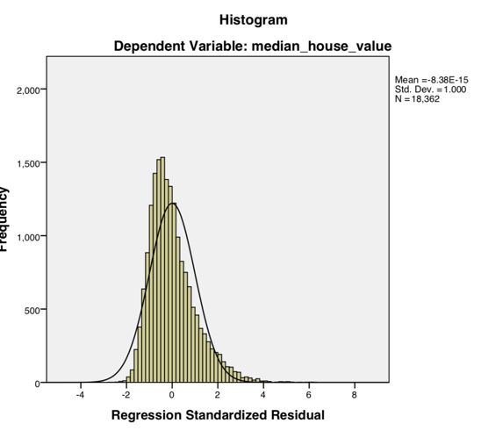

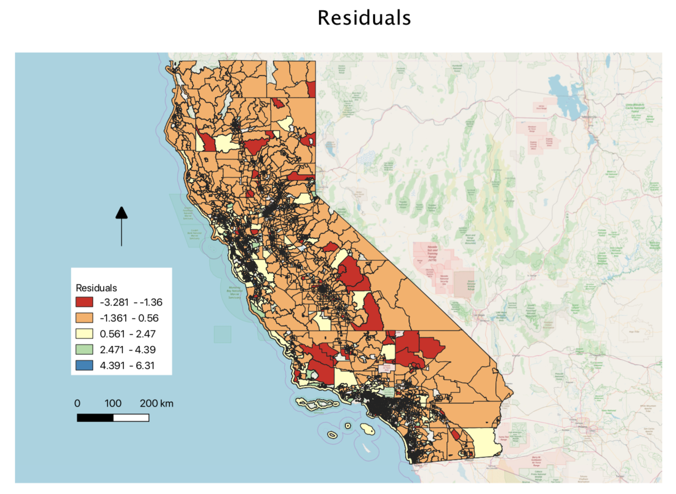

Above is the residual map for the regression model. Equal intervals were used to best represent the categories. Equal-intervals are less likely to hide the influence of outliers in the blocks and it was deemed suitable for this classification scheme.

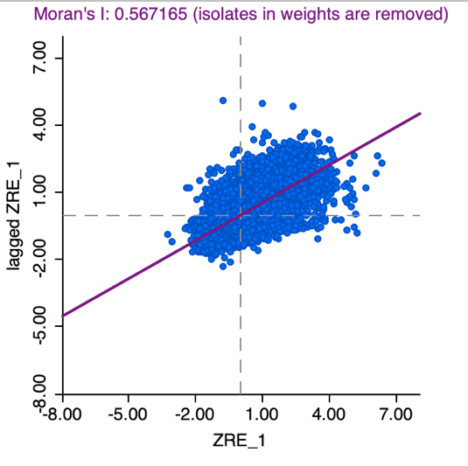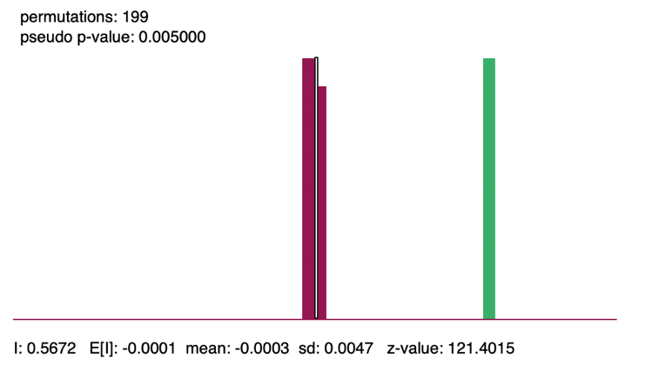

Above are the statistics for spatial autocorrelation. The Moran’s I value is 0.587, which indicates that this is clustering occurring in the residuals. In addition to this, the histogram of permutations of the Moran’s I value indicate that this trend is significant with a z-value of 121.4 and a p-value of 0.005.

**Discussion**

Several issues occurred when constructing this model. The first was having misshapen variables, that needed to be transformed. As a result, relationships between the independent variables that were transformed with the dependent variable changed greatly. This reduced the strength of the relationship between the dependent and the independents. What ultimately resulted in a low explanation from the model.

The second issue was the multicolinearlity that existed between the independent variables, population, total_rooms, total_bedrooms, and households. This was identified in the factor analysis when those variables collapsed into one another. After using this collapsed factor, it became apparent that the r-squared value was significantly lower. To mitigate this the collapsed factors were left out of the model and the lowest correlated variables were picked instead. By doing this action, the model’s r-square improved slightly.

Ultimately the model, not only fails to explain how median income, number of households, population, ocean_ proximity, and median house age influence household value but also fail to meet the assumptions of regression. Weak linear trends between the dependent and independent variables, using ordinal data instead of interval ratio, and possible not enough variables. In addition, this model failed to meet the assumptions of residuals by not being normally distributed, and being spatially dependent on one another.

Research regarding this next

Works Cited

Pace, R. Kelley and Ronald Barry, Sparse Spatial Autoregressions, Statistics and Probability Letters, 33 (1997) 291-297.

Géron, A. (2017) **Hands-on machine learning with Scikit-Learn and T**ensorFlow**.** O'Reilly Media, Inc.

**Appendix**

**Individual**

The only variables that should be considered individual are longitude and latitude since they themselves are a piece of a grid point.

**Aggregate**

The following variables are spatially aggregated together: housing median age, total rooms, total bedrooms, population, households, median income, median house value and ocean proximity. The reason these variables fall under this category is because of their descriptive quality. All of these variables are descripting block groups. For example, the population is the number of people living within the block group. This is a collection of individuals within a spatial unit.

**Implicitly spatial**

The following variables are implicitly spatial: housing median age, total rooms, total bedrooms, population, households, median income, and median house value. These variable describe the space rather than the space itself.

**Explicitly spatial**

The following variables are explicitly spatial: longitude, lattidue, and ocean proximity, because they are reference points on the globe where the other characteristic exist in.

**Sample**

All of the variables are sample data type. This is because not all houses were collected in this study and I myself threw out many of the observations from the original dataset because of their incomplete information.

**Population**

None of the variables are population data type because none of the represent the entire state housing environment in the year 1997.

**Discrete**

The following variables are discrete: Households, population, total rooms, total bedrooms. These variable would not make any sense if they were subdivided down to a further level.

**Continuous**

**Qualitative**

None of these variables are qualitative because they can be all measured with numerical values. I choose the change ocean proximity to a arbitrary type but it can be calculated via distance.

**Quantitative**

All of these variables are quantitative because they are all represented numerical and most of them would not make any sense expressed another way.

**Nominal**

None of my variables are nominal.

**Ordinal**

Ocean proximity is the closest variable to weakly ordinal because of my arbitrary numbering system. We know the categories are different and they are further away from the ocean but we do not know how far away just their rank.

**Interval**

The following variables have arbitrary zeros making them interval data types: longitude, and latitude.

**Ratio**

The following variables have a real zero that can be used to measure the magnitude between each observation. This also means that a negative value likely does not make any sense. Housing median age, total rooms, total bedrooms, population, households, median income median house value and ocean proximity.

**Univariate Analysis:**

**Dependent:**

 **Median House Value:**

Above are the plots of median home value. The shape of the dependent variable is best observed in the histogram. There is a rightward skewness of 0.82 and a flat kurtosis of 0.22. The mean of the data is at $189,276.06. Dispersion is best observed in the boxplot. The median line is right around where the mean of the data is, and the standard deviation is $95,340.72. The upper whisker of the boxplot is longer than the lower. Symmetry is best seen from the histogram. This variable is asymmetrical, because of the skewness. Normality is best visualized from the qq-plot. The variable does not fit the trend line and is not normal. More evidence for normality is expressed by the Shaprio Wilks and Kolmogorov-Smirnov tests. Both test reject the null hypothesis and indicate this variable is significantly different from a normal distribution. There are some outliers at the high end of the of the distribution as seen in the upper whiskers of the boxplot.

**Independent:**

**Longitude:**



Above are the plots of the variable Longitude. The shape of longitiude is best visualized by the histogram. There is a bimodal occurance happening in this variable because of the two peaks in the distribution. Measures of central tendency are best represented by a rightward skewness of -0.34 and a flat kurtosis of -1.25. The mean of the variable is at -119.49 degrees. The disperison of the variable is best observed in the boxplot. The second quartile is very large because the median line is towards the top of the interquartile range. The standard devation is 1.98 degrees. Both whiskers in the boxplot are of equal lengths. Symmetry is a qaulity this variable does not exhibit. Symmetry for this variable is nonexistant. The primisis for this arugment is dividing the histogram in half does leave two halves that are reflections of one another. Noramlity is best visuzlaized by the qq-plot. As seen above there are large devations from the red trend line, indicating that this vairable is not noramlly distributed. In addition to the qq-plot the Sharpio Wilks and Kolmogorov-Smirmov tests both indciate that this variable is significantly different from a normal distribution. There are no outliers to speak of in this variable because all observations are within one and half standard devations of the interquartile range.

**Latitude:**



Above are the plots for the variable latitude. The shape of latitude is best visualized by the histogram. There is a bimodal distribution in the histogram, because of the two peaks within the distribution. For measures of central tendency there is a leftward skew of 0.52 and a flat kurtosis of -1.05. The mean is also 35.59 degrees. Dispersion is best represented by the boxplot and by the standard deviation of 2.14 degrees. As seen in the interquartile range the second quartile is very large, because of the median line being very close to the first quartile. The upper whisker is much longer than the lower whisker because of the second peak seen in the histogram. Symmetry does not exist in this distribution because if you sliced the histogram in half there would not be to halves that reflect one another. Normality is best visualized by the qq-plot. Since the observations do not match the trend line this variable’s distribution is not normal. In addition to the qq-plot are the Shaprio Wilks and Kolmogorov-Smirnov tests both indicate that this distribution is significantly different from normal. For outliers there are none according to the boxplot because all are within one and half standard deviations of the interquartile range.

**Log Total Rooms:**

 Above is the variable total rooms after being transformed by natural log. The transformation changed the distribution of the observations to help meet the assumption of regression, variables should be normally disturbed. The shape of this variable’s distribution is best observed from the histogram with a leftward skew of -0.99 and with a peaked kurtosis of 5.06. This was changed from a severe rightward skewness of 4.18 and a very peaked kurtosis of 32.76. Although the skewness has not gotten much better the kurtosis is much more reasonable. For measures of dispersion observed in the box plot there is an equal length in the upper and lower whisker. The standard deviation can also be observed in the boxplot and represented numerically as 0.3215. There are more observations in the 3 quartile. The symmetry of this variable is best seen in the histogram and boxplot. There is a long tail and whisker with the majority of the values in the upper quartile of the distribution. What these features express about this variable is, symmetry does not exist here. Finally, normality is better in this form than in the raw variable. The Shaprio Wilks and Kolmogorov-Smirnov tests both indicate that the distribution is significantly different than normal but a large majority of the observations fall on the trend line. The decision to make this choice will possibly enable others to limit the data to make it even more normal.

**Log Population:**

Above is the population transformed by natural log. The transformation changed the distribution of the observations to help meet the assumption of regression, variables should be normally disturbed. The shape of population was improved by transforming this variable from a rightward skewness of 5.00 and a very peaked kurtosis of 73.04, to a leftward skewness of -1.04 and a peaked kurtosis of 4.69. The skewness is much better after the transformation and the kurtosis is flatter. As for dispersion best observed in the boxplot, there is a standard deviation of 0.317. As for the interquartile the median line is in the middle. For symmetry, the histogram and boxplot are very good indicators that this distribution is asymmetrical. However, the symmetry is much better in this transformed version because the skewness has been reduced considerably. Normality for this variable has not been fixed as a result of the transformation as indicated by the Shpario Wilks and Kolmogorov-Smirnov tests, which both indicate that there is a significant difference from a normal distribution. However, the qq-plot indicates a more normal distribution than in the original form. The indicator for this is the number of observations on the trend line.

**Log Households:**



Above is the transformed variable Households by the natural log. The transformation changed the distribution of the observations to help meet the assumption of regression, variables should be normally disturbed. The shape has been improved by doing this transformation as evidenced by an old rightward skewness of 3.38 and a very peaked kurtosis of 21.35, and now there is a leftward skewness of -1.05, and a peakness of 4.74. For dispersion of this transformed variable there is a standard deviation of 0.314. This is observed in the whiskers bounding the interquartile range. As for the median line within the second quartile, it is within the middle of the distribution. The symmetry of the distribution has been improved by the transformation, which is depicted in the histogram. However, there is asymmetry present for this variable, as seen in the histogram and boxplot tails. Normality has not be achieved by this transformation, because the Shaprio Wilks and Kolmogorov-Smirnov tests both indicate a significant difference from a normal distribution. However, observing the qq-plot more observations are aligned with the trend line than in the original untransformed variable.

**Log Median Income:**

Above is the transformed variable Median income. The transformation changed the distribution of the observations to help meet the assumption of regression, variables should be normally disturbed. As a result of the transformation the shape of the variable has improved significantly. The shape of this variable’s distribution is best observed from the histogram there is a leftward skewness of -0.35 and a flat kurtosis of 0.187. This was changed from a severe there is a rightward skewness of 0.90 and a flat kurtosis of 1.30. For dispersion the boxplot and histogram both reflect the improvement. Observing the interquartile range, the median line is right in the middle. The standard deviation is also 0.190. For symmetry the log transformation significantly helped but there is still a longer lower value tail in both the histogram and the boxplot. For normality, the transformation has helped significantly. According to the Shaprio Wilks test this is a normal distribution, but the Kolmogorov-Smirnov indicates that this distribution is significantly different from normal. Based on the qq-plot and the number of observations that fall along the trend line, there does seem to be normality.

**Total Bedrooms:**

Above is the variable total bedrooms per block. The shape of this variable is best visualized by the histogram because there is a rightward skewness of 3.42 and a very peaked kurtosis of 21.22. For measures of central tendency, the mean is 548.0 bedrooms per block. Dispersion can best be seen in the boxplot. The interquartile range is being pushed to the lower values of the boxplot because of the large frequency of lower values. The upper whisker is also slightly longer than the lower. Standard deviation for this variable is 429.50 bedrooms per block. This variable does not have symmetry because dividing the histogram in half does not yield to halves that are reflections of one another. Normality can be observed in the qq-plot. Since the observations do not follow the trend line there is sustainable evidence in the plot that this variable is not normally distributed. In addition to this the Shaprio Wilks and Kolmogorov-Smirnov test also show this variable is significantly different from a normal distribution. The outliers are heavily effecting this variable and can be seen in the boxplot above the upper whisker.

**Ocean Proximity:**

The reason why these graphs are strange and do not make much sense is because this is a categorical variable. The number has no relationship with distance from the coast. For symmetry it is clear that category 2 <1 ocean is the dominate category. This causes this particular histogram to look lopsided. Since the numbers were arbitrarily assigned the shape and symmetry of the graph is moot. Normality does not mean anything for this variable as well. The one good thing that comes from this graphic analysis of ocean_proximity is the indication of outliers in the boxplot. The category island is appearing above the upper whisker of the boxplot.

**Bivariate Analysis**

Based on the correlation table below the following variables that correlate strongest with median house value are: total_rooms at 0.175 and latitude at 0.175. This weak correlation with all other variables in the model could result in a violation of an assumption of regression that the independent and deponent variables have a linear relationship.

Other relationships that existed between independent variables were:

Latitude and Longitude at -.923

Total_rooms and total_bedrooms at .770

Population and total_rooms at .864

Population and total_bedrooms at .725

Households and total_rooms at .933

Households and total_bedrooms at .788

Households and popuatlion at .934

Median house value and median income at .63

**Correlation Matrix**

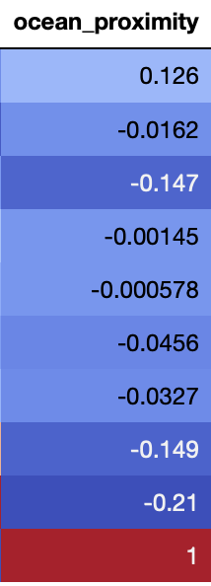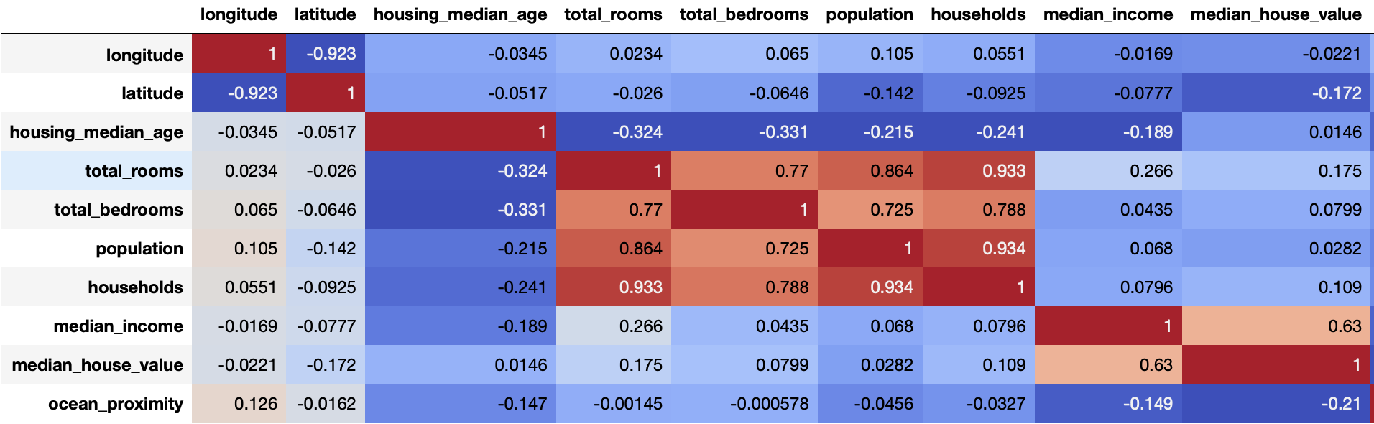

Below on the next page is the scatter matrix of variables plotted against one another. The few trends that do exists are between highly correlated variables, such as Latitude and Longitude at -.923, Total_rooms and total_bedrooms at .770, Population and total_rooms at .864, Population and total_bedrooms at .725, Households and total_rooms at .933, Households and total_bedrooms at .788, and Households and popuatlion at .934.

